CS102 | Spring 2008 | Project  Group | 4A
Instructor: | Markus Schaal | Project  Group | 4A
Assistant: | Sıtar Kortik | Project  Group | 4A

~ Math Operator ~

7
Ömer Sercan Arık
Bilgehan Avşer
Şükrü Burç Eryılmaz
Can Karakuş
Onur Günlü

User-Interface Design
(First Draft)

Introduction
It is necessary for people who work in engineering and science fields to perform complex mathematical operations. There is a large variety of computer programs that have been developed for that purpose such as Mathematica and Matlab. However, they in fact require a certain level of knowledge for programming language. We develop this program for both practical and educational purposes. This program can perform a broad range of operations such as finding limits at specified points, evaluating integrals and derivatives, sketching graph, solving equations and algebraic operations like summation or product, performing operations in complex and modular systems. In addition, a pop up window appears that has brief information about a mathematician inside it, which is very useful to motivate students and for educational purposes. The most significant point about our program is that it requires knowledge of mathematical notations rather than programming. The user can choose the operation and corresponding symbol by clicking, and also can enter numbers as in the actual notation.

Graphical User Interface

General Appearance
The general appearance of the user interface is illustrated in Figure 1. The window is basically divided into 6 areas. The first one, which is menu area, contains options involving saving/loading files, editing (cut/copy/paste/undo), toggling sub-windows and help files. Second one is toolbar, which is used to specify the mathematical operation to be performed. Third part is the interaction area, where the symbols of the current mathematical operation appear and user enters numbers and operators. Fourth part of window is plotting part, which visualizes the graphs, shaded areas and tangent lines which involve other features of program. Fifth area is the library part, where the functions are stored with specified names. Finally, the last part merely returns the numerical results of operations.
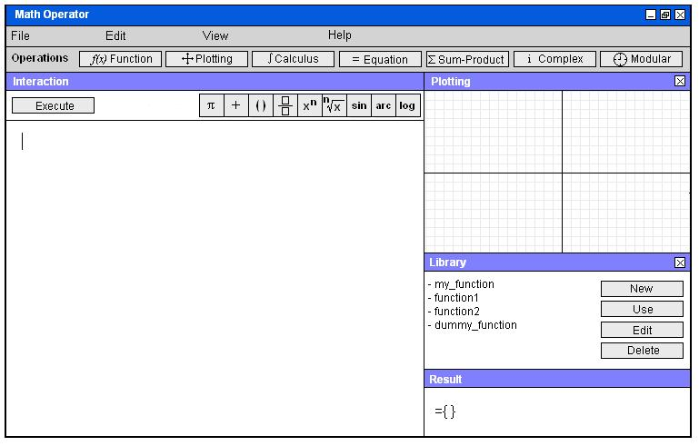
Figure 1 – General appearance of the program

Menus
Figure 2 shows the expanded versions of the top menus.
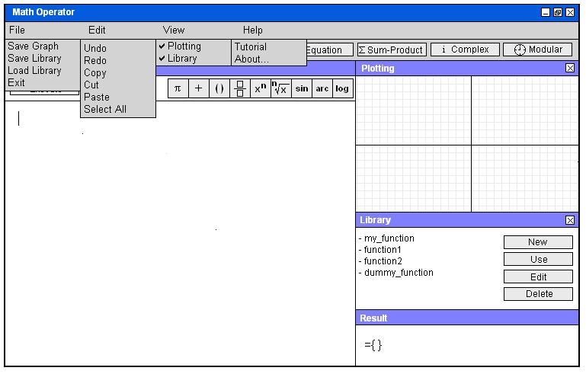
Figure 2 – Expanded versions of top menus
Save Graph option, which is under “File”, saves the sketched graph as a .jpeg file to the directory of program. The user specifies file name interacting with the window shown in Figure 3.
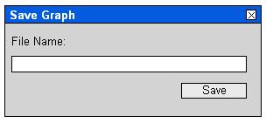
Figure 3 – Graph Saving Window
Save Library option saves the current function library to the program directory (Figure 4). The user can later load a function set to the program by loading a library (Figure 5).
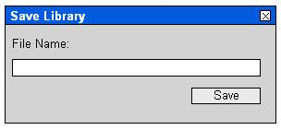
Figure 4 – Library Saving Window
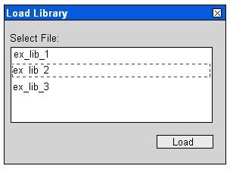
Figure 5 – Library Loading Window
Plotting and Library options under “View” menu toggle the corresponding windows on or off. About… option under “Help” opens a window showing credits, and Tutorial option is obviously a manual to use the program.

Toolbar
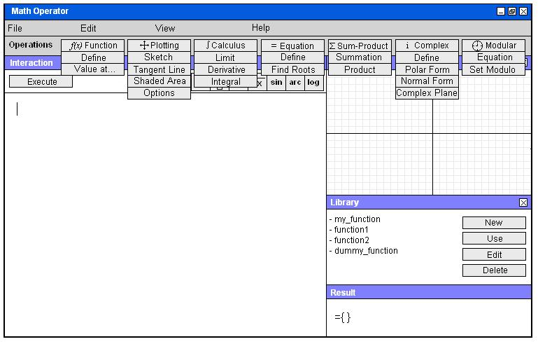
Figure 6 – Expanded View of Toolbar
Toolbar provides a large variety of mathematical operations and easy navigation. The expanded version of the options in toolbar is shown in Figure 6, which reveals most of the functions of the program. These features and their usage will be explained in detail in following next sections.

Operators Bar
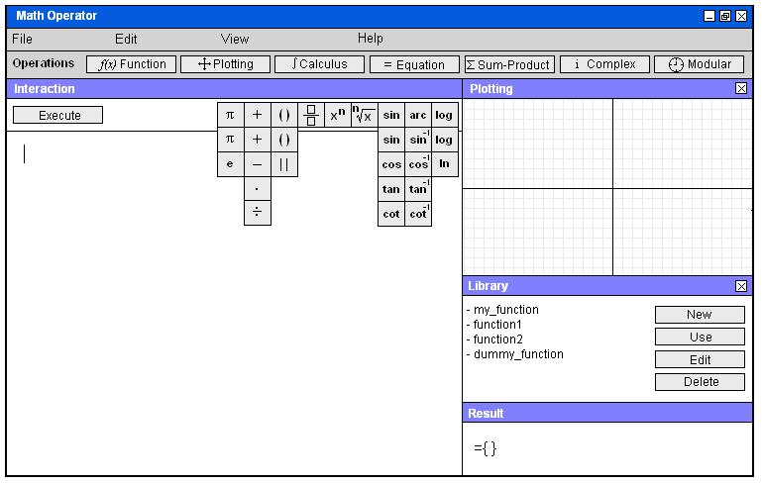
Figure 7 – Expansion of Operators Bar
Figure 7 illustrates the simple mathematical operators that the user will utilize in order to perform algebraic operations, define functions etc. The exact usage of these tools will be explained in detail in the following sections.

Direct Algebraic Operations
Without specifying an operation from toolbar, the user can directly use the interaction area and Operators Bar to write an algebraic operation and execute it. Execution is done using “Execute” button located at the top of the interaction area. An example usage is illustrated in Figures 8-15.
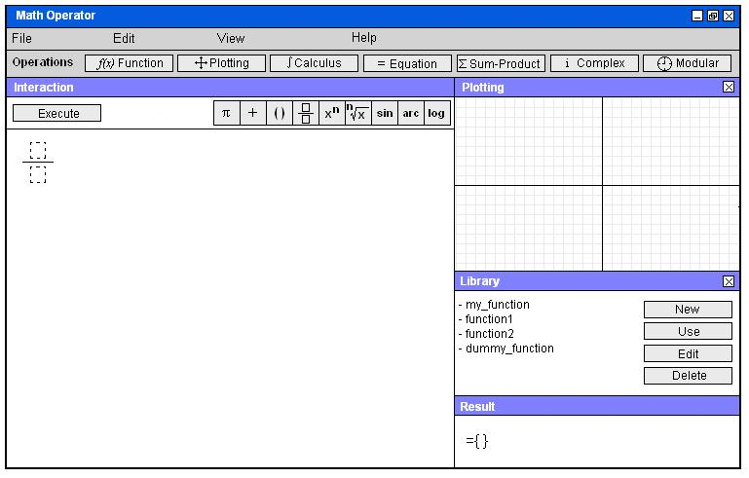
Figure 8 – Sample screenshot 1 for direct algebraic operation
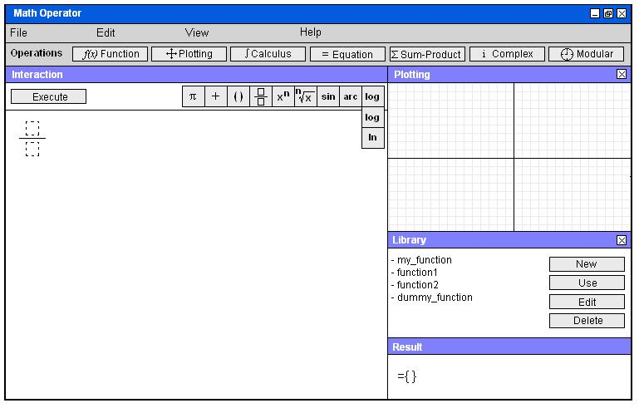
Figure 9 – Sample screenshot 2 for direct algebraic operation
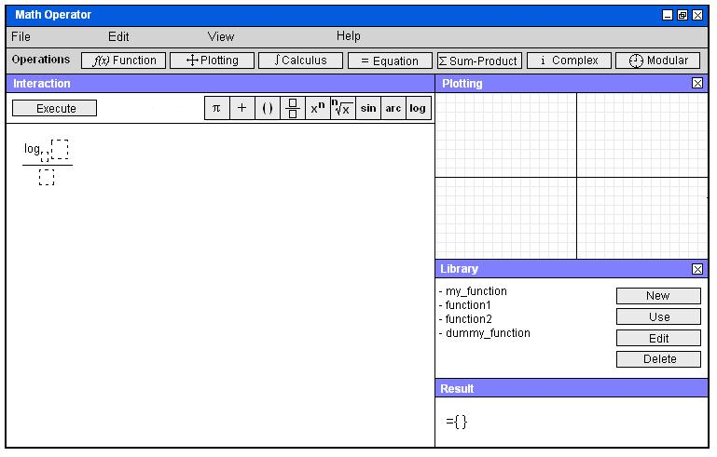
Figure 10 – Sample screenshot 3 for direct algebraic operation

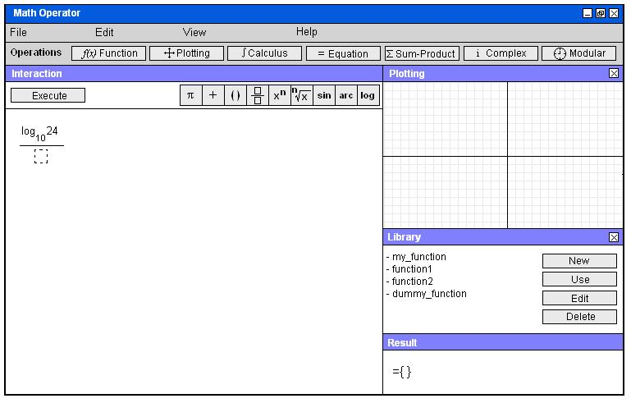
Figure 11 – Sample screenshot 4 for direct algebraic operation

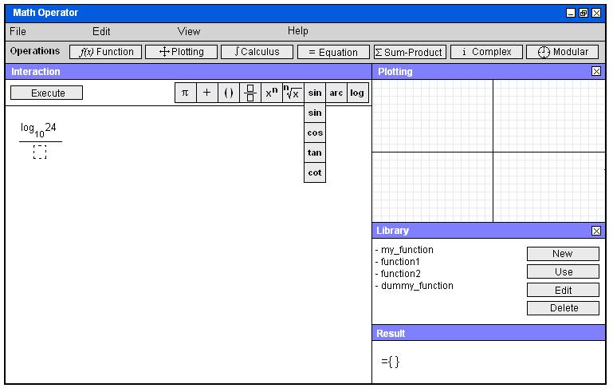
Figure 12 - Sample screenshot 5 for direct algebraic operation
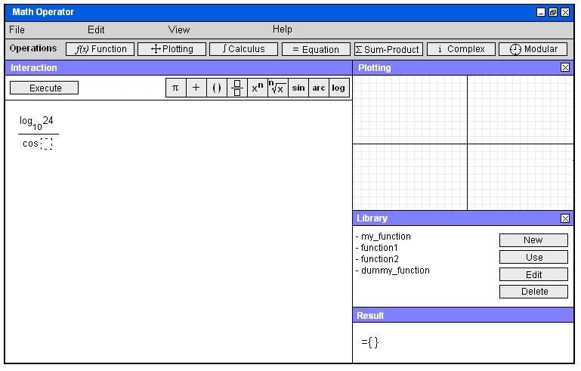
Figure 13 - Sample screenshot 6 for direct algebraic operation
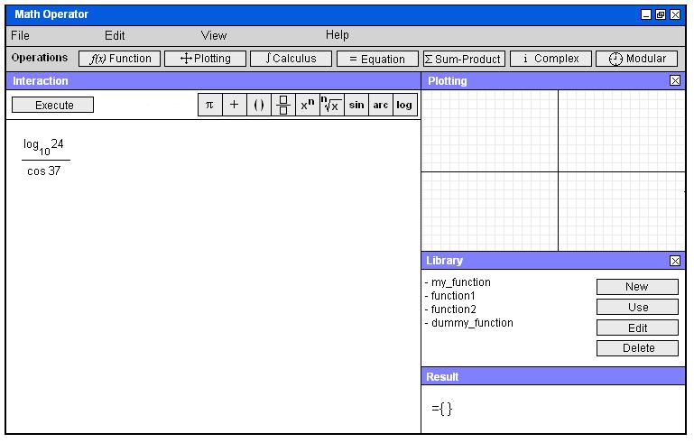
Figure 14 - Sample screenshot 7 for direct algebraic operation

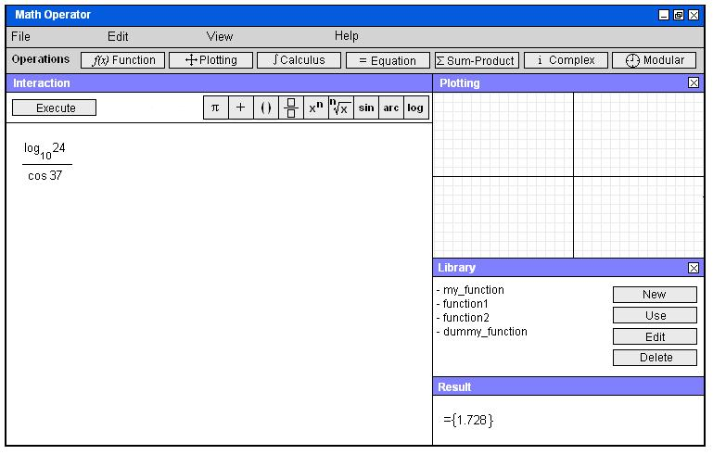
Figure 15 - Sample screenshot 8 for direct algebraic operation
As instructed in this sequence of figures, in order to place an operator, the user first clicks the relevant button on the Operators Bar, and a box appears along with the symbol of desired operator. These boxes are used throughout the program, indicating that the user should enter numerical values or operators in these areas. In this particular example, the user chooses a fraction, a logarithm and a cosine function, fills in the required boxes and executes the program.

Function

Defining a Function
In order to define a function, user simply clicks on the “Function” button from the Toolbar, and chooses “Define” option. The program will return f(x)= in the interaction area, and a box to fill in using numbers or operators. The user fills in the right-hand side to define a function as exemplified in Figures 16-23.
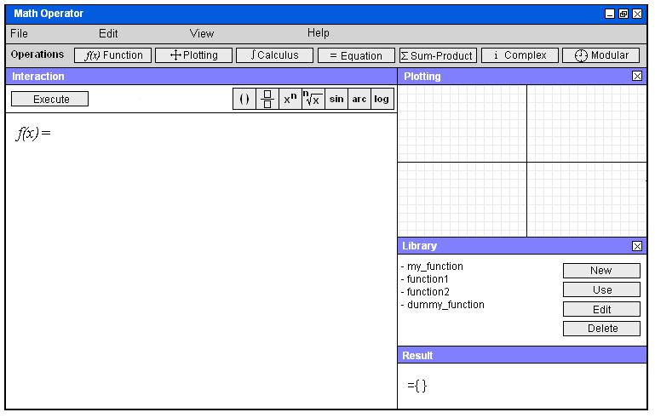
Figure 16 – Sample screenshot 1 for defining a function

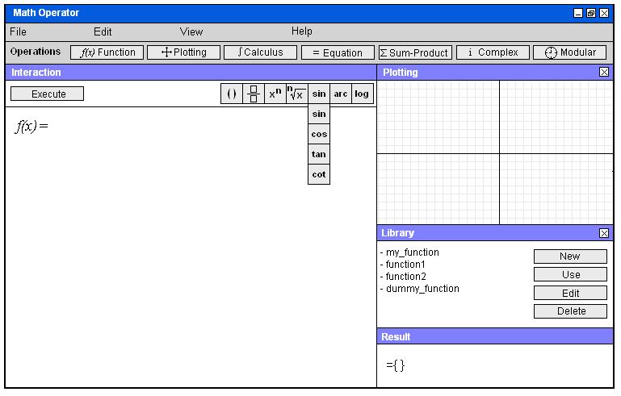
Figure 17 – Sample screenshot 2 for defining a function
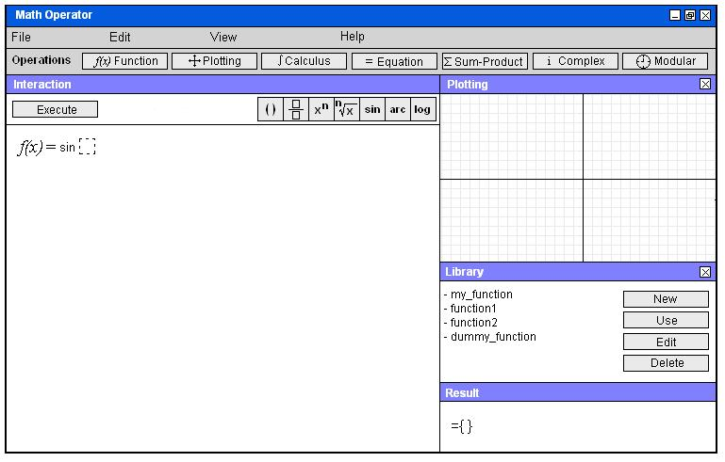
Figure 18 – Sample screenshot 3 for defining a function
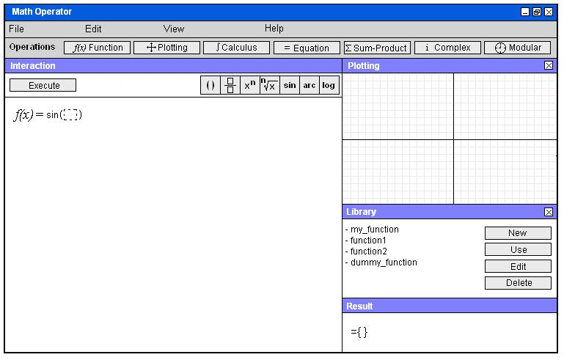
Figure 19 - Sample screenshot 4 for defining a function
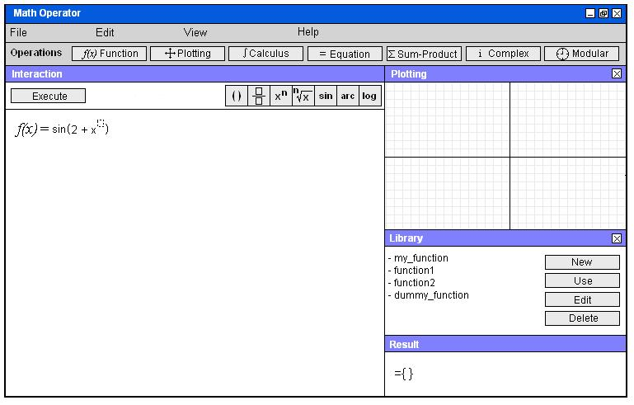
Figure 20 - Sample screenshot 5 for defining a function
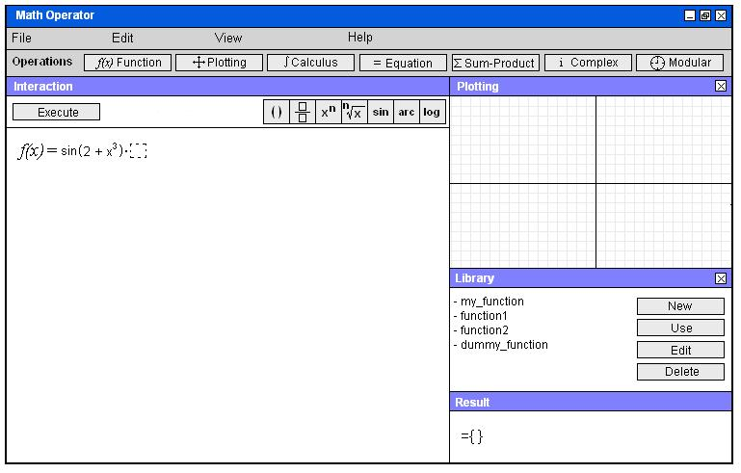
Figure 21 - Sample screenshot 6 for defining a function

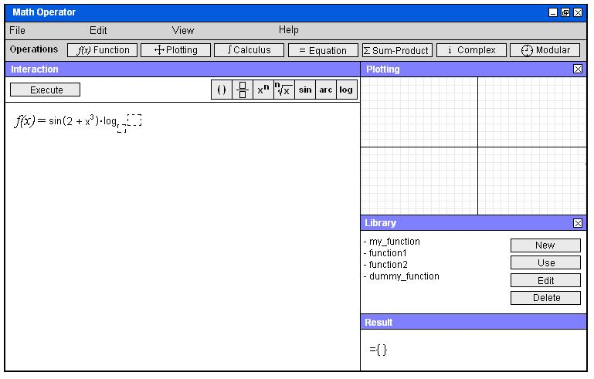
Figure 22 – Sample screenshot 7 for defining a function

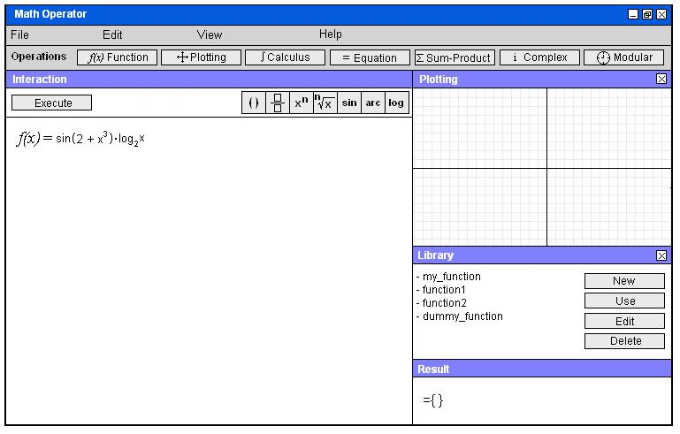
Figure 23 - Sample screenshot 8 for defining a function

The user uses “x” as the variable while defining functions.
If the user would like to find the value of the function defined at a specified point, (s)he can simply choose the “Value at…” option under Function button, and interacting with the window shown in Figure 24, specifies the point and obtains the value at Result sub-window (Figure 25).
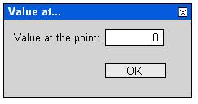
Figure 24 – Function Value Interaction Window
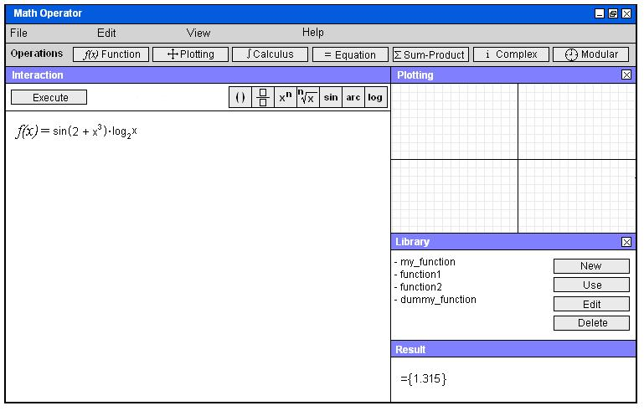
Figure 25 – The value of the function at the specified point

Library
The program provides a function library to store the defined functions with names. User can save and load a function library. To add a defined function to the current library, user clicks the “New” button from Library sub-window, and interacting with the window shown in Figure 26, enters a name for function.
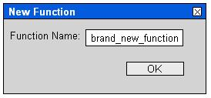
Figure 26 – Interaction window used to add a function to library
After clicking OK, the name of the function appears on the function list on the Library sub-window (Figure 27).
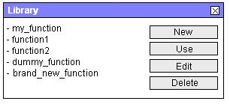
Figure 27 – Function list after adding a new function
After adding a function, user can choose a function from list by simply clicking on it and after clicking “Use”, the function appears at the interaction part. “Edit” button is used in order to rename the function (Figures 28, 29).
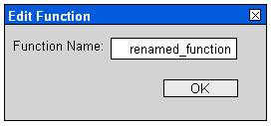
Figure 28 – Renaming window for library functions
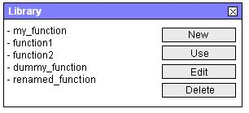
Figure 29 – Function list after renaming the function

User can also delete a function using “Delete” button, and confirming his decision (Figure 30).
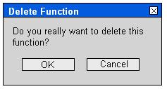
Figure 30 – Confirmation window for deleting a library function

Plotting

Sketching Graphs of Functions
The user can plot a defined function. In order to perform this, the user clicks the “Plotting” button at the Toolbar, and chooses “Sketch” option. The plot of the function appears on the Plotting sub-window (Figures 31, 32).
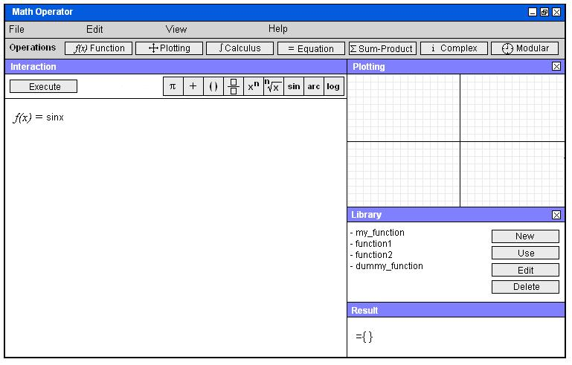
Figure 31 – User enters the function whose graph will be sketched
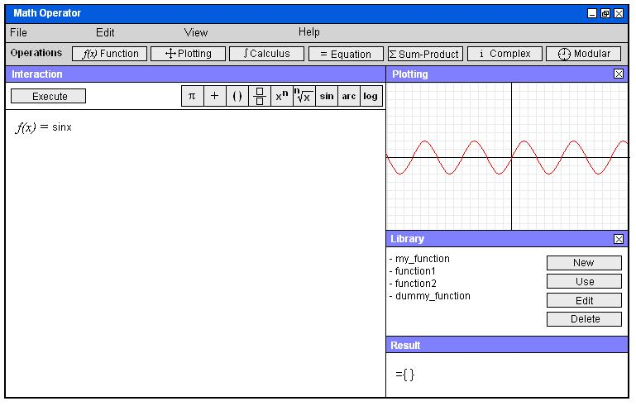
Figure 32 – Graph appears at the Plotting sub-window

Visualizing Shaded Areas for Integrals
After evaluating an integral (which will be explained in the following sections), the user can visualize the shaded area corresponding to that integral on the graph of the integrand (Figure 33). In order to do that, user should only click “Shaded” button under Plotting menu after evaluating the integral.
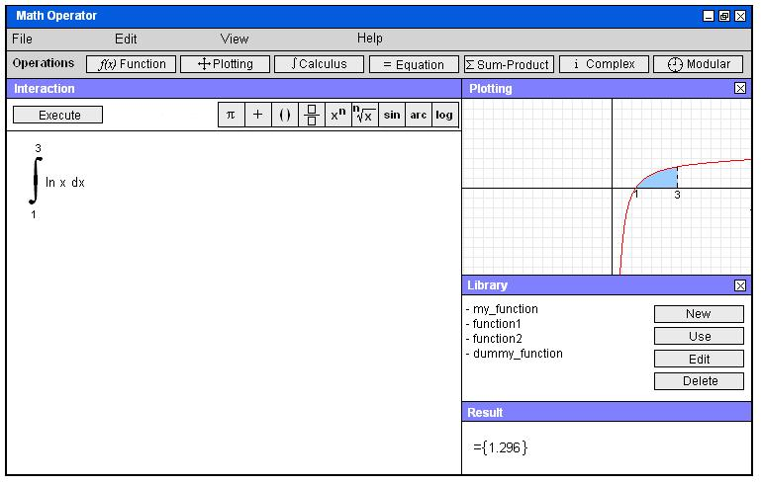
Figure 33 – Visualization of the shaded area corresponding the evaluated integral

Visualizing Tangent Lines for Derivatives
After evaluating a derivative (which will be explained in the following sections), the user can visualize the tangent line corresponding to that derivative on the graph of the function (Figure 34). In order to do that, user should only click “Tangent” button under Plotting menu after evaluating the derivative.
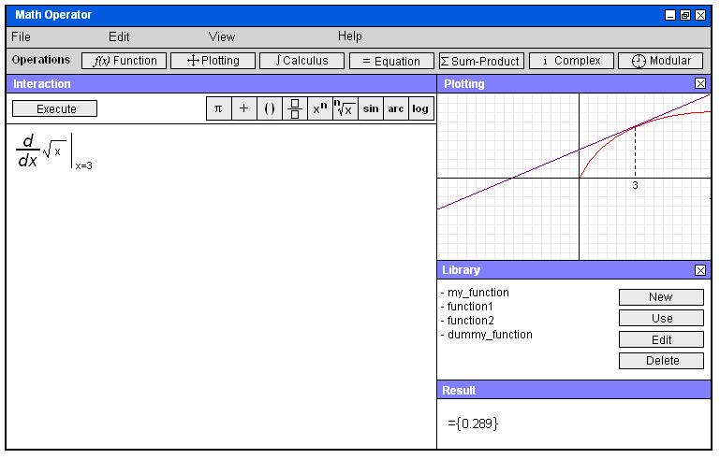
Figure 34 - Visualization of the tangent line corresponding the evaluated derivative

Plotting Options
The user can specify the color and scale of the graph using the “Options” under Plotting menu. User enters the length that a unit square represents by specifying the scale (Figure 35).
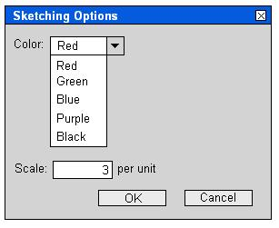
Figure 35 – Plotting options window

Calculus

Limit
After choosing “Limit” option under Calculus menu, the the proper notation for limit (Figure 36) appears. Again, at certain areas, there are boxes for the user to enter numbers or operators (using “x” as the variable). After entering the required data, clicking on the Execute button will return the value of the limit. (Figures 36-39)
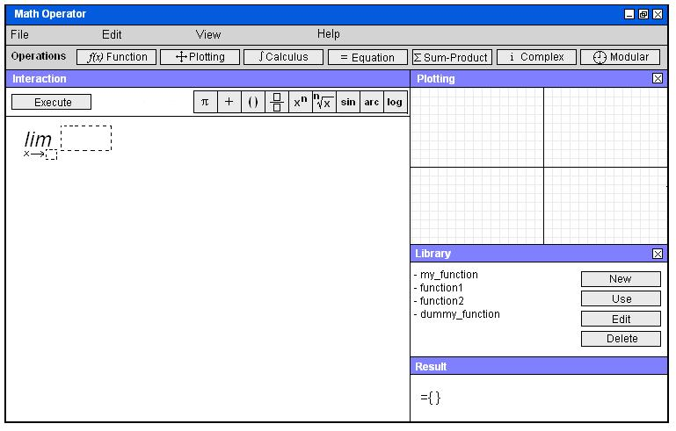
Figure 36 – Sample screenshot 1 for evaluating limits

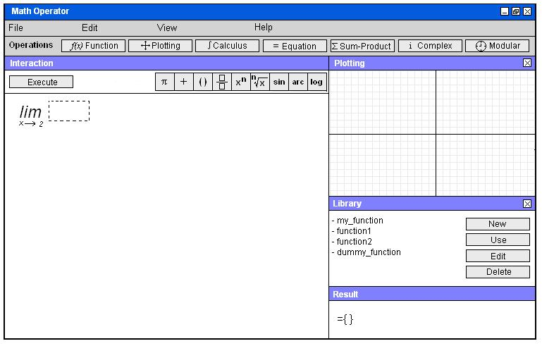
Figure 37 – Sample screenshot 2 for evaluating limits
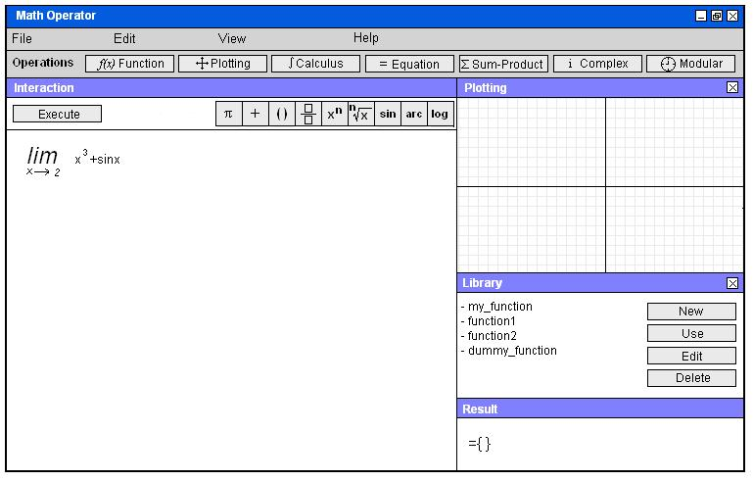
Figure 38 – Sample screenshot 3 for evaluating limits
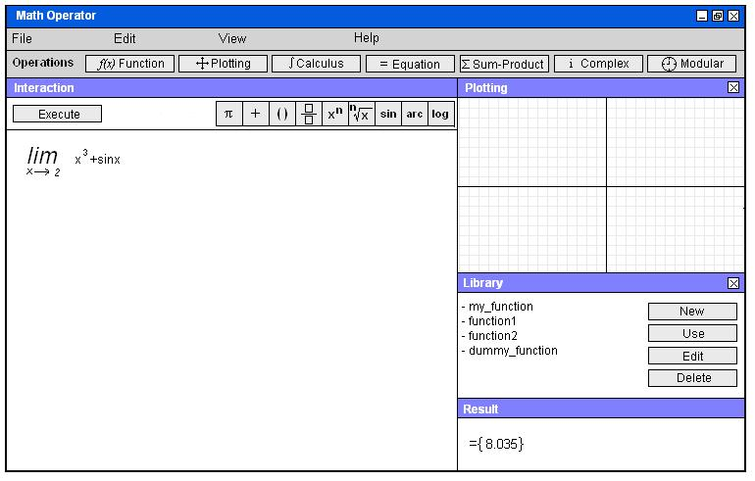
Figure 39 - Sample screenshot 4 for evaluating limits

Derivative
To evaluate a derivative, the user chooses Derivative option under Calculus menu, and the proper notation appears at the interaction sub-window. Again, user fills in the boxes using numerical values and operators (using “x” as the variable), and clicks execute button in order the program to return the value of the derivative. Figures 40-42 exemplify this operation.
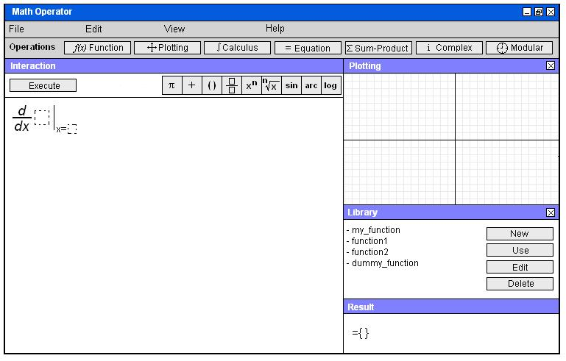
Figure 40 – Sample screenshot 1 for evaluating derivative
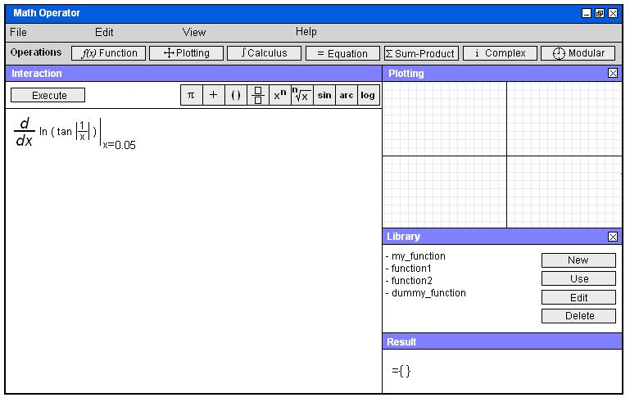
Figure 41 – Sample screenshot 2 for evaluating derivative

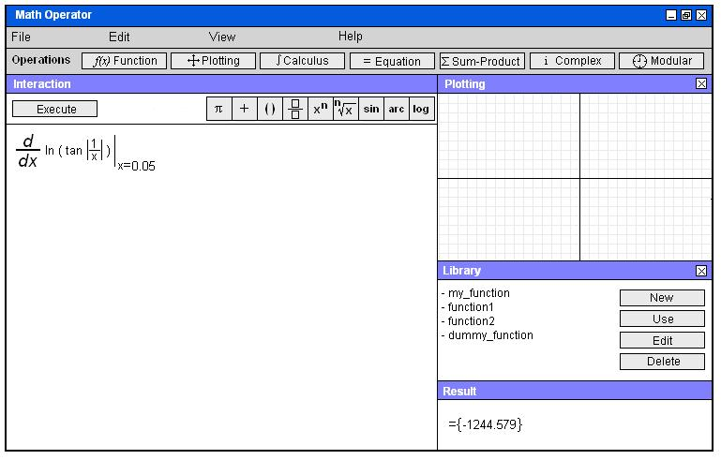
Figure 42 – Sample screenshot 3 for evaluating derivative

Integral
To evaluate an integral, the user chooses Integral option under Calculus menu, and the proper notation appears at the interaction sub-window. Again, user fills in the boxes using numerical values and operators (using “x” as the variable), and clicks execute button in order the program to return the value of the integral. Figures 43-46 exemplify this operation.
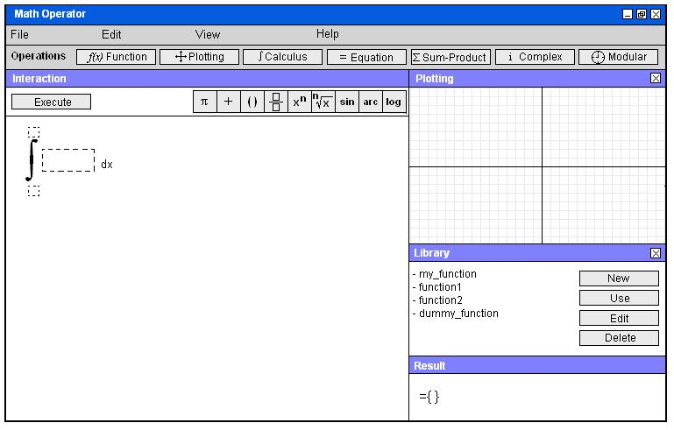
Figure 43 – Sample screenshot 1 for evaluating integral
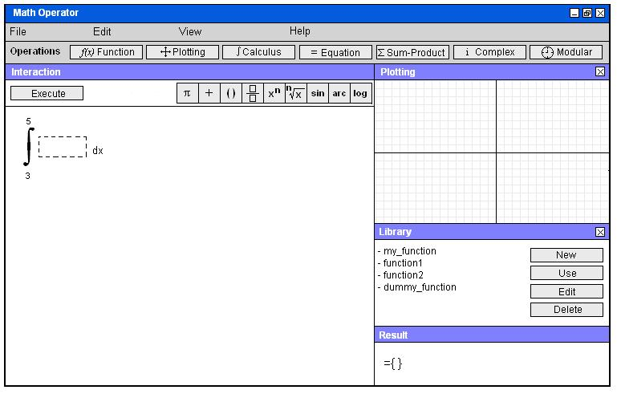
Figure 44 – Sample screenshot 2 for evaluating integral
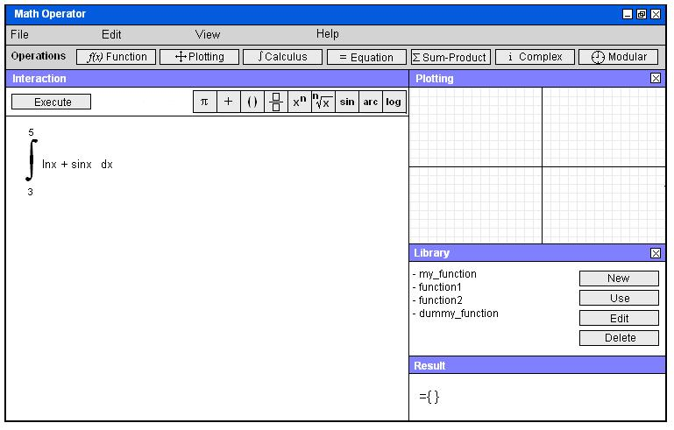
Figure 45 – Sample screenshot 3 for evaluating integral
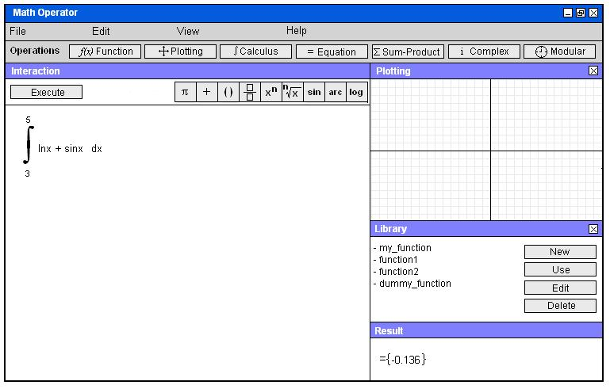
Figure 46 – Sample screenshot 4 for evaluating integral

Equations
The program will be able to find the roots of equations up to 3rd degree. In order to specify an equation, user first clicks “Define” button under “Equation” menu. The program displays the proper notation at the interaction area. User enters numerical values and operators (using “x” as the variable) to the blank boxes. After that, choosing “Find Roots” option under “Equation” menu will return the roots, if any exists, at the Result sub-window. If there is no root, this will be reported at the result sub-window. Figures 47-50 show a sample root finding operation.
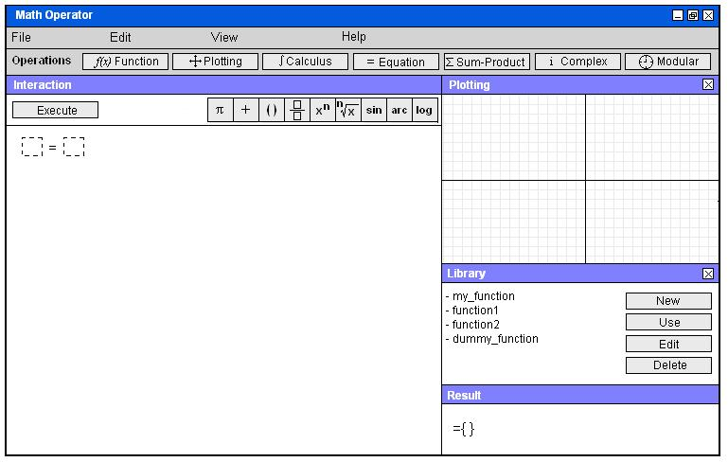
Figure 47 – Sample screenshot 1 for solving equations
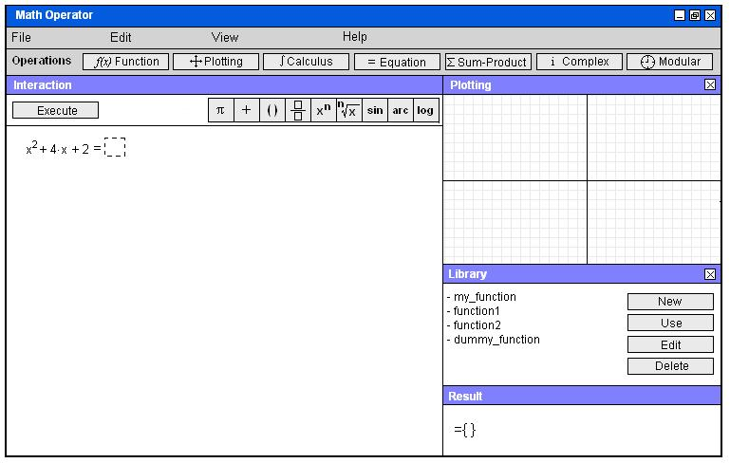
Figure 48 – Sample screenshot 2 for solving equations

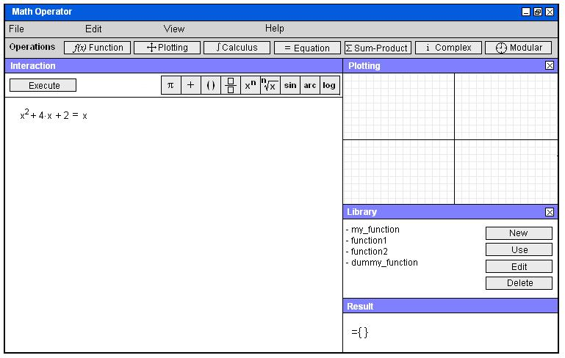
Figure 49 – Sample screenshot 3 for solving equations

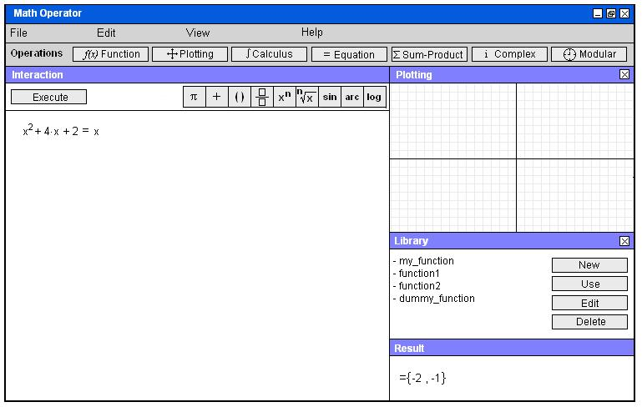
Figure 50 – Sample screenshot 4 for solving equations

Sum-Product
User clicks the “Sum-Product” menu, and choose either “Summation” or “Product” option. Using operators, numerical values (and “x” as the variable), user fills in the blank boxes; and clicks the “Execute” button to perform the summation or product operation. Figures 51-54 illustrate this operation.

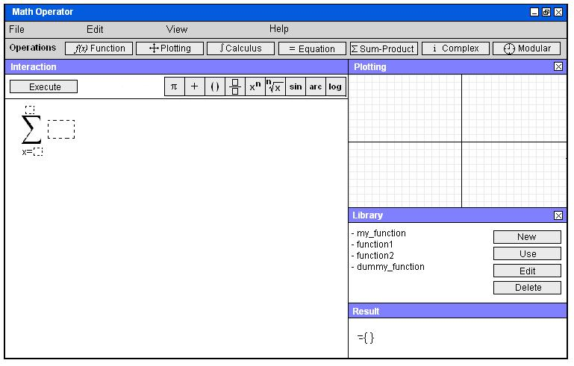
Figure 51 – Sample screenshot 1 for summation operation
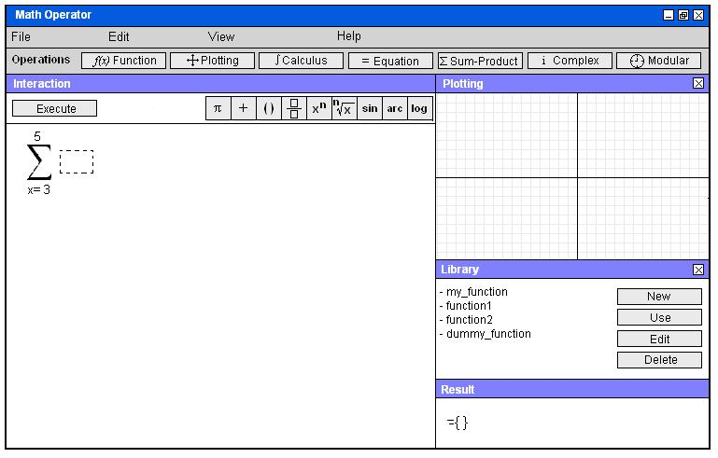
Figure 52 – Sample screenshot 2 for summation operation
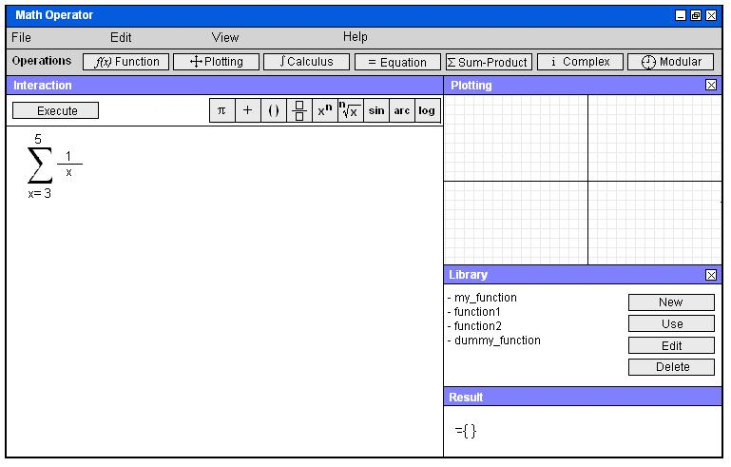
Figure 53 – Sample screenshot 3 for summation operation
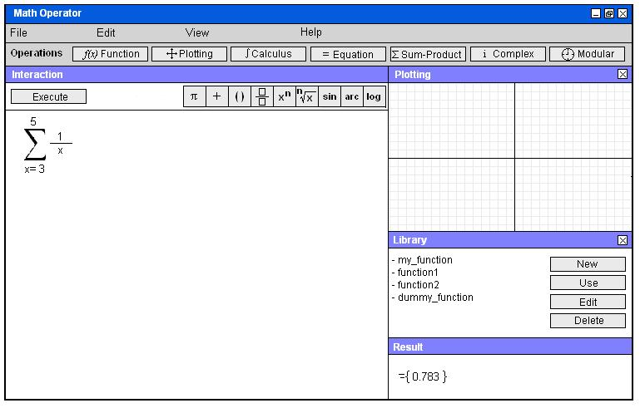
Figure 54 – Sample screenshot 4 for summation operation

Complex Numbers
The program supports performing operations involving complex (imaginary) numbers. To define an imaginary number, user chooses “Define” option under “Complex”, and the imaginary unit (i) appears with a blank box in front of it. The user can specify the coefficient of i by filling in this blank box. After that, he can do simple calculations involving this imaginary number by using the operators at the Operator Bar. Figures 55-58 illustrate an example usage of complex number feature.

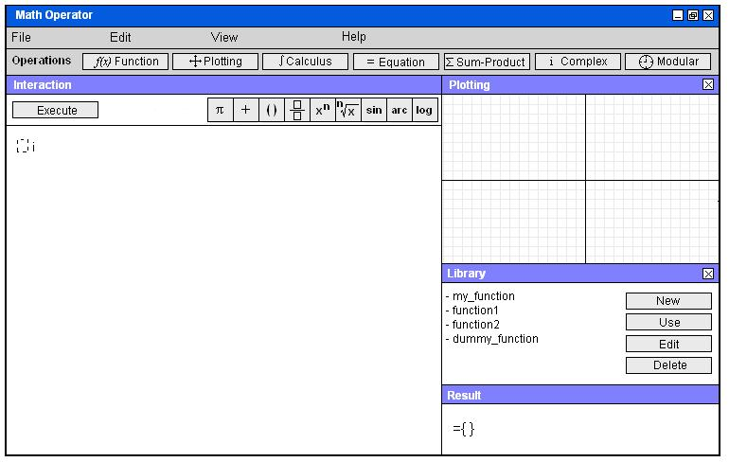
Figure 55 - Sample screenshot 1 for complex number calculations

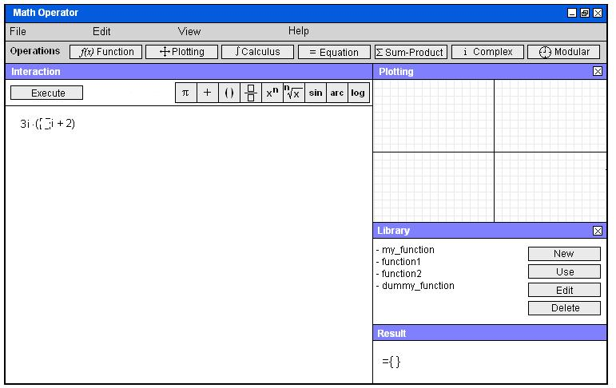
Figure 56 - Sample screenshot 2 for complex number calculations
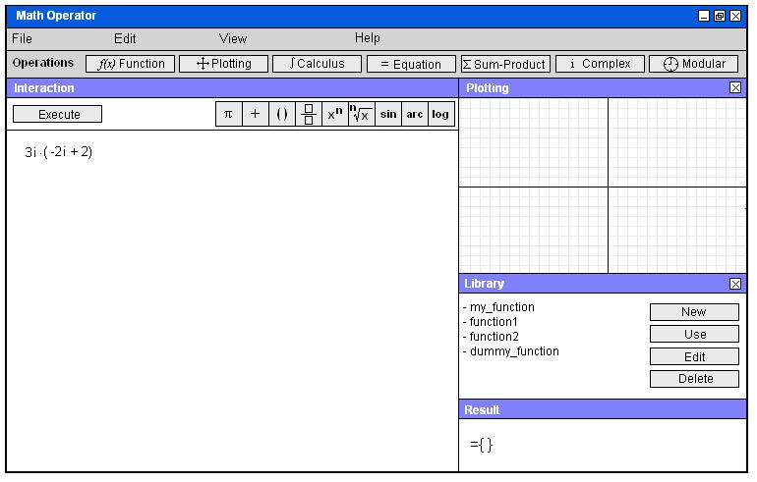
Figure 57 - Sample screenshot 3 for complex number calculations

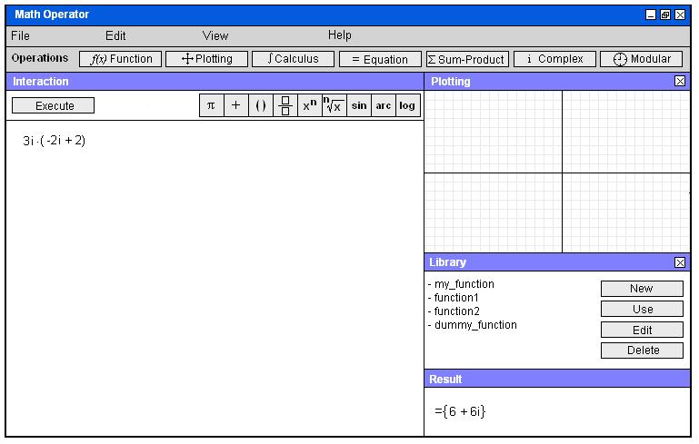
Figure 58 - Sample screenshot 4 for complex number calculations

Polar Form/Normal Form
The user can toggle between polar and normal forms of complex numbers for the calculated result by choosing “Polar Form” and “Normal Form” options under “Complex” menu (Figure 59).

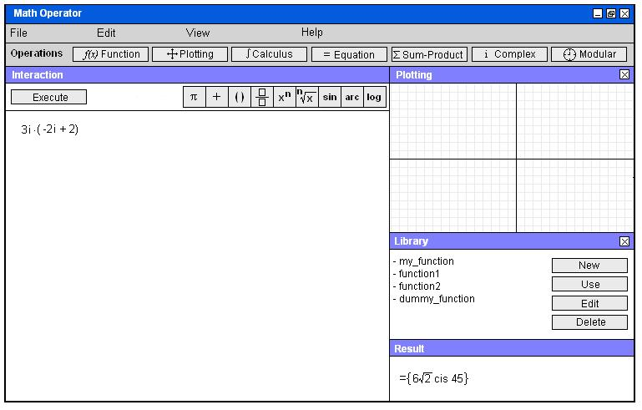
Figure 59 – Toggling the result to polar form

Complex Plane
User can also view the complex number on the complex plane by choosing “Complex Plane” option under the menu (Figure 60).

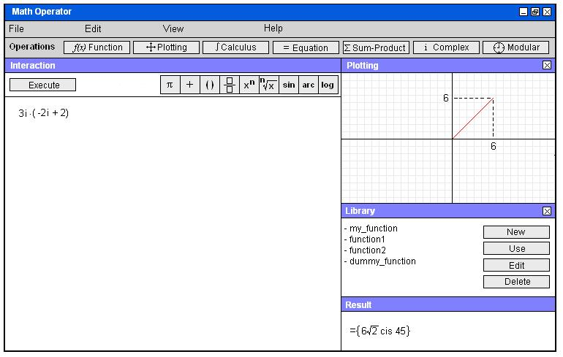
Figure 60 – The complex number viewed on the complex plane

Modular Arithmetic

Algebra
The user can perform direct algebraic operations by setting a modulo. In this case, all the calculations are made in accordance with this modulo as long as only integers are involved in the operation. If the result is not an integer, the program will return an error message. In order to do this, user first clicks the “Modular” menu, and then chooses “Algebra” option. The program prompts user to specify the modulo (Figure 61). Then, user enters the algebraic expressions and clicks “Execute” (Figures 62, 63). User can later change the modulo by choosing “Set modulo” option.
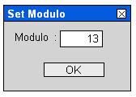
Figure 61 – Modulo specifying window

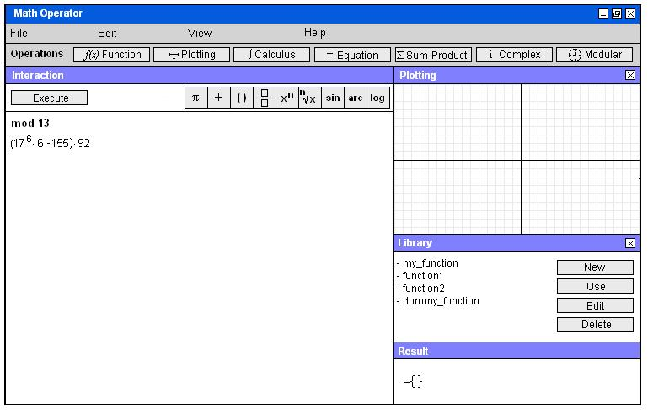
Figure 62 – Sample screenshot 1 for the modular algebraic operations
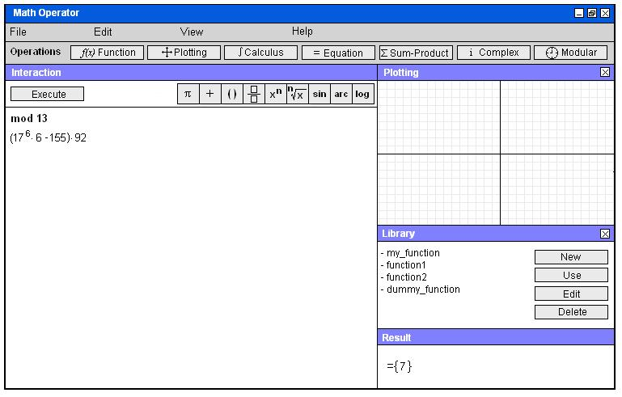
Figure 63 - Sample screenshot 2 for the modular algebraic operations

Equation
If the user chooses “Equation” option under “Modular” menu, the program again prompts user for the modulo as shown in Figure 61. After the specification of the modulo, the proper notation appears at the interaction area. User fills in the blank boxes to enter the equation, and as long as the roots are integers, the program will return the result(s) in accordance with this modulo (Figures 64-66). Otherwise, it will return an error message.

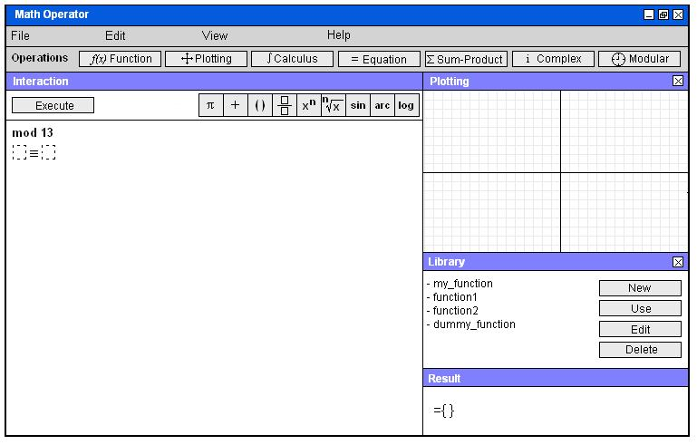
Figure 64 – Sample screenshot 1 for modular equation
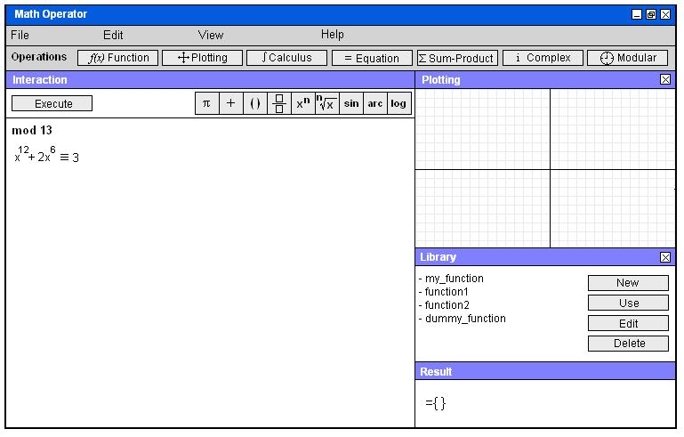
Figure 65 – Sample screenshot 2 for modular equation
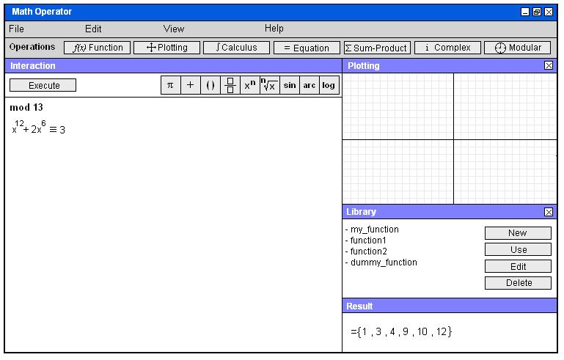
Figure 66 – Sample screenshot 3 for modular equation

Pop-up Info
Each time the program is launched, a pop-up window will appear, and give a brief information about an important mathematician (Figure 67). Clicking “Skip” in this window will direct user to the program (Figure 1).
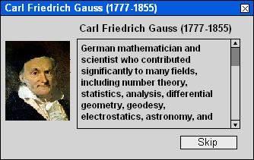
Figure 67 – Pop-up info about an important mathematician

Summary & Conclusions
This program is intended as a tool to facilitate fundamental mathematical calculations and operations and to be used by students and engineers for both educational and practical purposes. Our report demonstrates graphical interaction between the program and the user in a detailed way for any of the operation the program can perform. The most significant point about the user interface is that the notations are very similar to those used in actual mathematical notations rather than a programming language. The program also responds to the user by options that appear sequentially in a logical manner, after each of user’s choice; this is another characteristic of the interface that is compatible with exact order of mathematical operation. Thus, this program is a simple-to-use, user interactive program which combines the visual aids

